How to... add a blog post
One of your regular tasks is blogging. After each role-play, some of you will have to blog about their experiences during the role play and the perspectives of their roles.
To add a blog post, you need to log into your blog account. Please go to the lower right corner and click on Log In. Use your username and the password you specified. If you haven't set a password yet, please go to How to.... register for the blog. After login, you enter the dashboard and go to Post on the left side of the dashboard. Click on Add New. Now, you enter the blogging space, where you can add your text (in the text space) and insert images by clicking on Add Media.
There are certain points you should take care of before publishing your contribution. Please follow these instructions as they ensure that your post is easy to find and fits into the overall concept.
- Do not use clear names. When writing about your group members or classmates, use the user names listed under Users (on the left side of the dashboard).
- Set a featured image by clicking Featured Image in the lower right corner of the Add New pane. You must create this image first. For more details, please read How to... create a Featured Image. For the first blog entry, the Featured image will be provided.
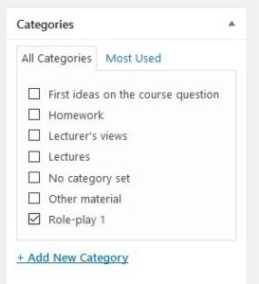
- Specify your category. If you publish a role-play related post, use the category 2019/Role-play X. For any other post, use one of the other categories. Please make sure you select a category, as your blog post will only appear on the home page, but not anywhere else if you do not select a category.
- Choose tags. They should make it easier for readers to find your posts. The tag ideas will usually be the featured content tag, meaning that posts with this tag will appear in the front banner on the Home page. Make sure to click on Add.
- Remove any sharing check marks.
- Publish your contribution as password-protected. To do this, go to the upper right corner and click on Visibility and Password Protection. Enter the password and click on Publish. The password to use will be communicated to you in class. If you browse through last year's contributions, you will notice that these contributions are public. They were also password-protected at the time they were created. After class, we decided together with the students to publish them.
- Do not hurt any copyright. Do not upload anything, which is not yours and link content clearly stating the origin.
- Make sure, your post appears.
If you run into any problems, get in contact with the course coordination.

